GCP CLOUD GURU

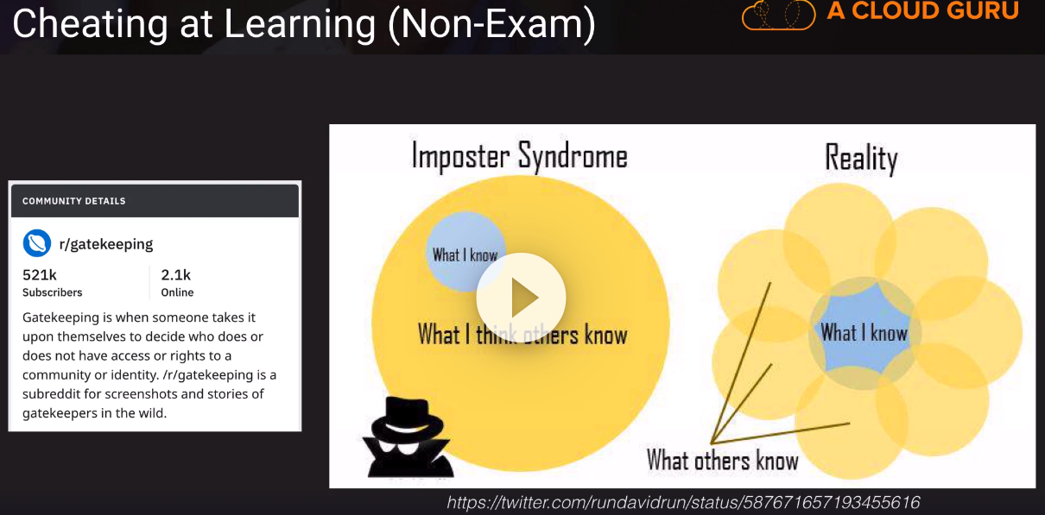

<https://learn.acloud.guru/cloud-playground/cloud-sandboxes>

Cap05 - Milestone - Start

<https://acloud.guru/forums/gcp-certified-associate-cloud-engineer/discussion/-LHq7ia97ot7POrc6Nw7/exam_report_mega-thread>